***Choose Your Own Adventure Game***

* Game Theme: Escaping a forgotten dungeon
* Image to sum up game theme:

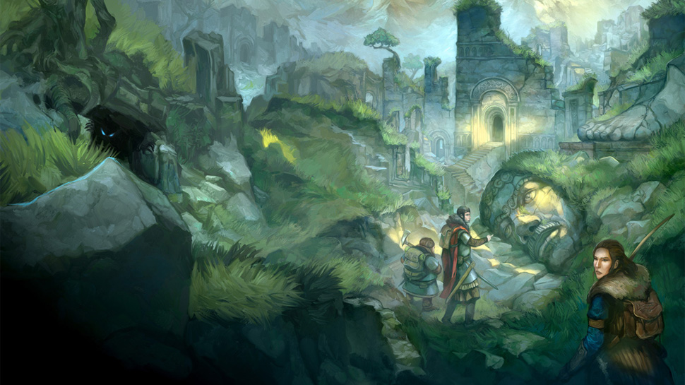

* A girl archer. Inspiration:

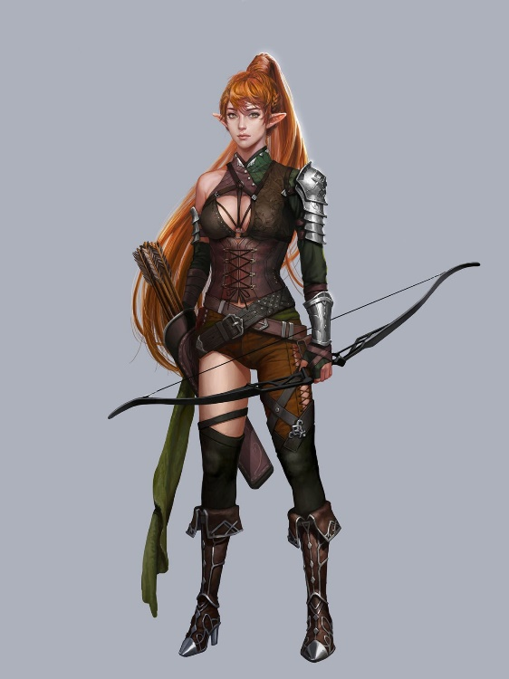

* Goal: Escape the dungeon